PROJECT MAIKHAN 75MW-100MW PUMPED STORAGE HYDROPOWER
GREEN ENERGY & DATA ECOSYSTEM
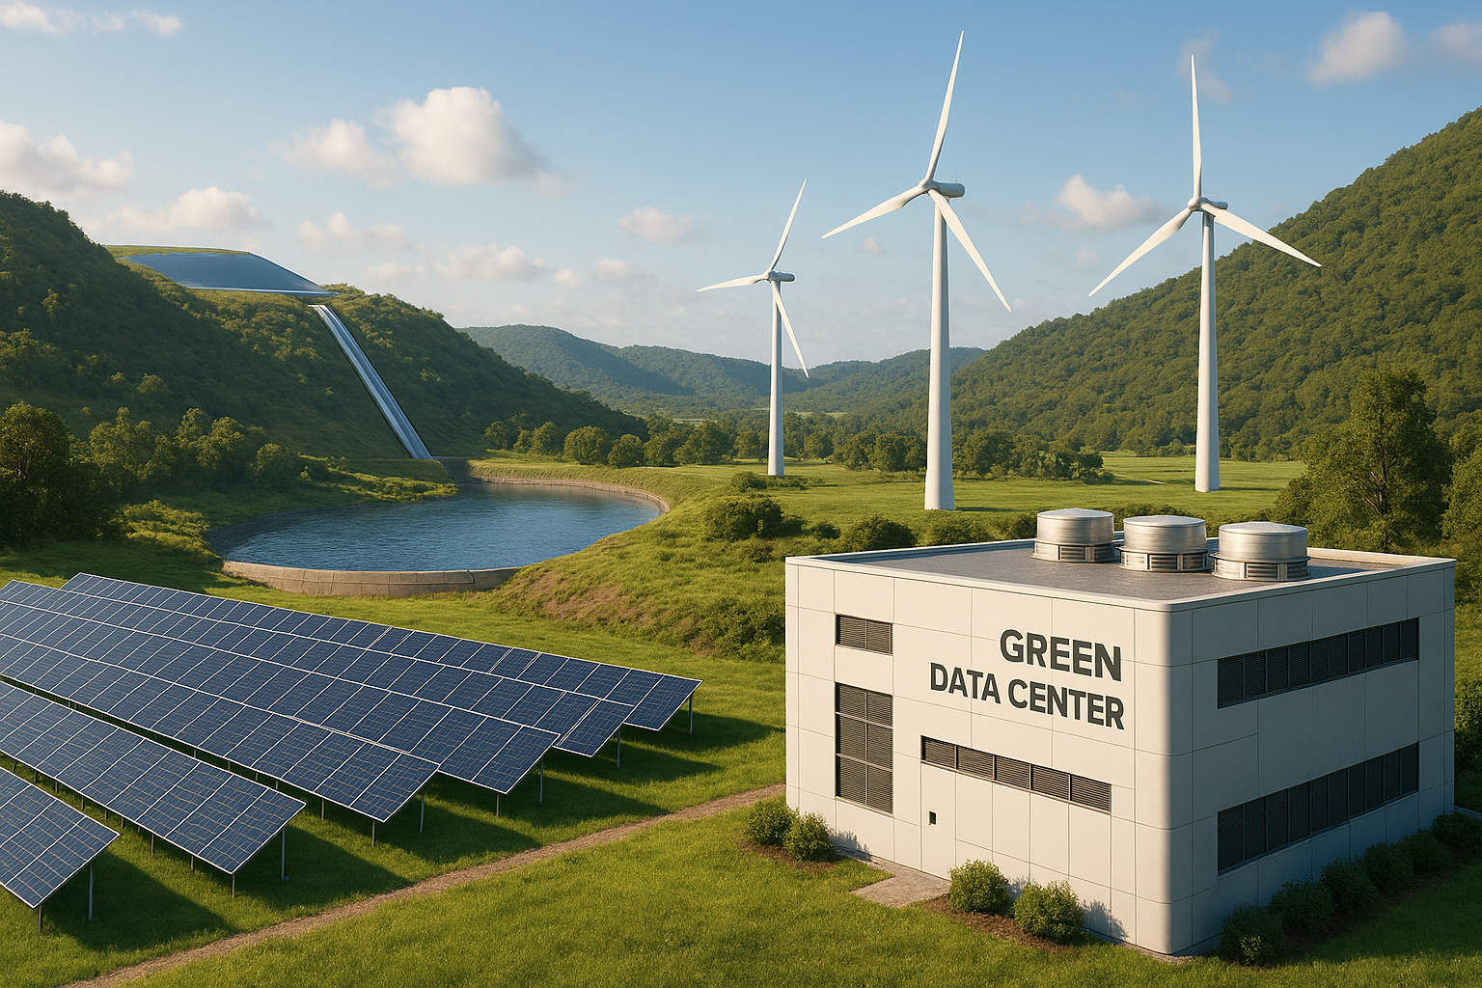
PHASE: 1 – PHASE 4
BRIEF INTRO, INVESTMENT MEMORANDUM

MONWORLD LTD
OWNER’S REPRESENTATIVE | FINANCIAL ARRANGER | PROJECT MANAGEMENT OFFICE (PMO)
SUNHYDRO LLC
LICENSE HOLDER & PROJECT DEVELOPER
CONTACT: ADMIN@MONWORLDGROUP.COM | +44 7769 398914

EXECUTIVE SUMMARY
Monworld Ltd (Owner’s Representative & Financial Arranger) and Sunhydro LLC present a phased infrastructure investment opportunity: Project Maikhan.
Project Maikhan is a vertically integrated Green Energy Ecosystem located approximately 37 km from Ulaanbaatar. The ecosystem anchors on a pumped storage hydropower (PSH) plant designed to provide immediate grid balancing and ancillary services, and expands into a hybrid renewable energy complex powering a Tier-rated Green Data Centre.
We are seeking USD 111.2 million for Phase 1 (Core Infrastructure). This investment enables delivery of the foundational 75 MW PSH asset with a defined upgrade pathway to 100 MW, followed by renewable integration (Phase 2) and PSH scale-up to 200 MW (Phase 3) to support national grid needs and the Green Data Centre roadmap (Phase 4).
- Phase 1 (Core PSH): 75 MW (3 × 25 MW) — fully permitted with tariffs and PPA approved.
- 100 MW option: immediate upgrade pathway enabled by current design basis and pumping load capability (103 MW); subject to feasibility amendment and procurement optimization post-financial close.
- Phase 2 (Hybrid renewables): wind 15–20 MW; solar ~30 MW; BESS 5–10 MW.
- Phase 3 (Scale-up): PSH expansion to 200 MW with additional penstocks, larger units, and reservoir capacity increases.
- Phase 4 (Commercialization): Tier-rated Green Data Centre anchored to stable, low-carbon power.
PHASE 1: CORE PSH INFRASTRUCTURE (CURRENT PROJECT)
The foundation of the ecosystem is the Maikhan Pumped Storage Hydropower plant. Phase 1 is fully permitted and positioned as shovel-ready for construction execution following detailed design finalization and contracting.
APPROVED CONFIGURATION (75 MW)
- Capacity: 75 MW (3 × 25 MW turbine-generator units).
- Grid connection: 25 km, 220 kV transmission line to the Ulaanbaatar substation (approved).
- Approvals: Feasibility Study approved; EIA approved; land possession approved; construction license approved.
- Commercial framework: purchase/sale tariffs approved by the Energy Regulatory Commission; Power Purchase Agreement (PPA) approved.
- System studies: National Dispatching Center operating regime assessment completed; technical conditions issued for grid connection.
UPGRADE OPTION (100 MW) — INCLUDED AS A DEFINED PATHWAY
An upgrade to 100 MW is identified as an executable option following financing, leveraging the existing civil and hydraulic concept and the design basis pumping load capability of 103 MW. The upgrade is primarily an electromechanical optimization (unit sizing and associated electrical equipment) with limited changes to core civil works, subject to final detailed design and a formal amendment to the Feasibility Study.
- Rationale: current concept supports 103 MW pumping load; reservoirs and core civil works are designed with sufficient robustness to support higher generation output.
- Scope impact: electromechanical equipment selection, transformer/switchgear sizing checks, protection & control settings, and grid interface confirmation.
- Execution status: contingent on financial close and Feasibility Study amendment; included as an option in procurement specifications to preserve pricing and delivery flexibility.
- Procurement note: long-lead contracts should include a 100 MW option (or modular expansion provisions) where feasible.
PHASE 2: HYBRID RENEWABLE INTEGRATION
Following PSH commissioning, the project expands into a hybrid renewable energy park, using PSH to smooth intermittency, reduce reliance on grid energy for pumping, and strengthen green certification for downstream data centre development.
Target Capacities
- Wind power: 15–20 MW (utilizing site elevation and wind corridor).
- Solar power: ~30 MW (installed on suitable slopes and near reservoir vicinity).
- Battery Energy Storage System (BESS): 5–10 MW (rapid frequency response and short-duration bridging).
Strategic Value
- Reduces net grid draw for pumping through onsite renewable generation.
- Improves system flexibility and supports ancillary service delivery.
- Strengthens eligibility for green certification and supports lower delivered power cost to the data centre.
PHASE 3: PSH EXPANSION (SCALE-UP)
To support increasing national grid flexibility requirements and the energy demand of the broader ecosystem, the PSH facility is planned to expand to 200 MW.
- Target capacity: expansion to 200 MW.
- Infrastructure: additional penstocks and installation of larger turbine units.
- Reservoir expansion concept: increase lower reservoir to 2.5–3.0 million m³ and increase upper reservoir by ~1.0 million m³ (subject to detailed feasibility and permitting for Phase 3).

PHASE 4: GREEN DATA CENTRE (COMMERCIALIZATION)
The ecosystem’s commercial anchor is a high-tier Green Data Centre supported by stable, low-carbon electricity.
- Asset: development of a Tier-rated Green Data Centre.
- Power source: hybrid renewables (Phase 2) stabilized by PSH (Phase 3), supplemented by the central grid as required.
- Competitive advantages: stable electricity supply and favorable cooling conditions in Mongolia’s climate.
PHASE 1 FINANCIAL OVERVIEW
The Phase 1 investment ask focuses on delivery of the 75 MW PSH facility as the foundational asset for the full roadmap. Capital structure referenced in the project materials is 10% equity and 90% debt with a 15-year loan tenor at 6% interest (indicative).
- Total power plant project cost (Phase 1 core): USD 111.2 million.
- Indicative structure: 10% equity / 90% debt.
- Indicative loan terms: 15 years @ 6% interest.
- Sponsor case returns: NPV USD 55.6 million; IRR (WACC) 10.84%; discounted payback 8.2 years.
Sources and Uses of Funds (Phase 1)
Category | Description | Cost (Million USD)
Construction | Civil works for dams, reservoirs, site preparation | 82.00
Equipment | Turbines, pumps, electro-mechanical | 14.96
Buildings | Powerhouse (approx. 1,500 m²) and technical buildings | 5.14
Housing | Worker housing and offices | 3.00
Subtotal (EPC Contract Value) | EPC contract value | 105.10
Project Costs | General implementation and management | 4.00
Supervision | Engineering and construction supervision (Monworld Ltd) | 2.10
TOTAL ASK | Phase 1 core investment | 111.20

Note: Transmission infrastructure (~USD 15.38M) and additional direct project costs, non-project costs, and feasibility costs are presented as separate items in the project materials (total project cost reported at ~USD 135.12M). These may be structured as separate tranches or equity contributions depending on lender requirements and final contracting strategy.

EXECUTION PLAN: DESIGN AND PROCUREMENT READINESS
Preliminary technical parameters and system studies are established. Detailed engineering, tendering, and long-lead procurement should be executed under an Owner’s Engineer-led process aligned with the selected contracting strategy. Procurement should explicitly preserve the 100 MW option.
- Mobilize Owner’s Engineer; confirm design basis, interfaces, and contracting strategy (single EPC or split packages).
- Execute detailed design packages (civil, hydraulic, mechanical, electrical, protection/control) and geotechnical follow-up as required.
- Launch vendor pre-qualification and RFQs for long-lead items; reserve manufacturing slots via staged deposits.
- Award EPC and long-lead contracts; mobilize construction; maintain an upgrade-ready procurement position for 100 MW.
LONG-LEAD PROCUREMENT (INDICATIVE WINDOWS)
- Turbine-pump units: RFQ Month 1; award Month 6; delivery 12–18 months (include 100 MW option provisions).
- Transformers: RFQ Month 2; award Month 7; delivery 9–12 months.
- HV switchgear and protection: RFQ Month 2; award Month 6; delivery 6–9 months.
- SCADA/control systems: RFQ Month 3; award Month 7; delivery 6–9 months.
- Penstock steel and valves: RFQ Month 3; award Month 7; delivery 6–12 months.

CONTACT INFORMATION:
MONWORLD LTD
OWNER’S REPRESENTATIVE | FINANCIAL ARRANGER | PMO
EMAIL: ADMIN@MONWORLDGROUP.COM
TEL: +44 7769 398914
SUNHYDRO LLC
PROJECT DEVELOPER & LICENSE HOLDER

